_{PAOLA CIGNA}
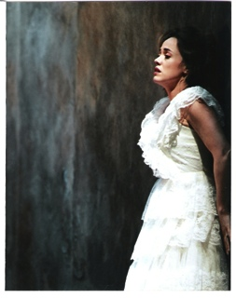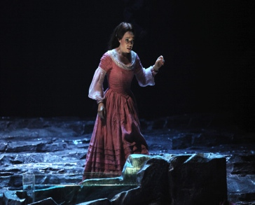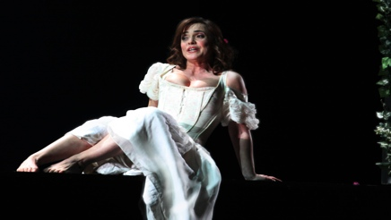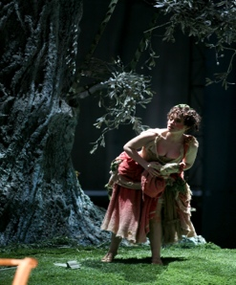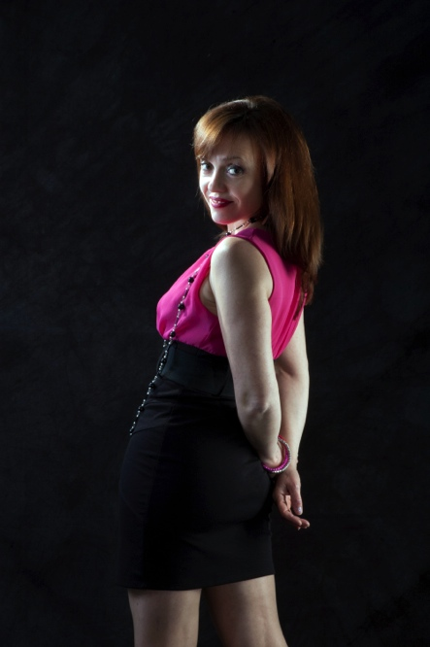
_{Via Sillaro 22/4}
40050 Monterenzio Bologna Italia
₊₃₉₀₅₁₉₂₉₂₀₈
₊₃₉₃₄₇₃₄₁₄₁₈₂
_{info@paolacigna.com}
_{paolacigna@icloud.com}
_{paola.cigna@tiscali.it}
_{plcigna@hotmail.com}
_{www.paolacigna.com}

Paola Cigna was born in Volterra (Pisa), she studied with Jolanda Meneguzzer. She graduated with top marks and mention at the “Luigi Cherubini” Conservatory in Florence under Walter Alberti.
She won prizes at following conpetitions: first prize “Lina Pagliughi” in Cesena (Italy), second prize “Tito Schipa” in Lecce (Italy), first prize “Prima Scrittura” in Florence (Italy), second prize “Francisco Viñas” in Barcelona (Spain), and second prize ”Leyla Gencer” in Istanbul (Turkey).
In 1996 she made her debut at the “Teatro Comunale “ in Modena with Francesco Gnecco’s “La prova di un opera seria” and at the Theatre in Lille and “Opera Comique” in Paris with Vivaldi’s “Juditha thriumpans” conducted by J.C. Malgoire.

She has guested as LUCIA (Lucia di Lammermoor), Serpina (La Serva Padrona), Giacinta (La Locandiera), Zerlina (Don Giovanni), Despina (Così fan tutte), Barbarina and Susanna (Le nozze di Figaro), Pamina and Papagena (Die Zauberflöte), Frasquita (Carmen), Adina (L'elisir d'amore), Norina (Don Pasquale), Rita (Rita), Eleonora (Il Furioso all’isola di San Domingo), Amina (La Sonnambula), Giulietta (I Capuleti ed i Montecchi), Adalgisa (Norma), Rosina (Il Barbiere di Siviglia), Dorliska (Torvaldo e Dorliska), Corinna (Il Viaggio a Reims), Donna Fulvia (La pietra del paragone), Gilda (Rigoletto), Violetta (La Traviata), Oscar ( Gustavo III as well as Un ballo in maschera), Anna ( Nabucco), Lauretta (Gianni Schicchi), Liù (Turandot), Lisette (La Rondine), Musetta (La Bohème), Lei (La notte di un Nevrastenico), Der Hüter der Schwelle des Temple (Die Frau ohne Schatten), Adele (Die Fledermaus), Lisa (Gräfin Mariza), Galathee (Die Schöne Galathee), Cilla (Il Socrate immaginario), Susanna (Il Segreto di Susanna).
Her last debuts were BLONDCHEN in Die Enfhührung aus dem Serail at Pafos Aphrodite Festival Cyprus, LUISA in Luisa Miller and MICAELA in Carmen at theTheater “Amintore Galli” in Rimini .
She sang in the world premiere of Angelo Russo’s “Vittoria sul Sole” and in Roberto Solci's “Nove icone per una Madre” for “Ravenna Festival” .

She sang, among others, at the “Teatro alla Scala” in Milan, “Teatro Comunale” in Bologna, “Luciano Pavarotti” in Modena, Teatro “Municipale” in Piacenza, “Teatro Donizetti” in Bergamo, Teatro “Verdi” in Busseto, Teatro “Carlo Felice” in Genova, “S. Carlo” in Naples, Teatro “Alighieri” in Ravenna, “Lingotto” in Torino, Teatro “Niccolini” and “Pergola” in Florence, Teatro “”Del Giglio” in Lucca, Teatro “Goldoni” in Livorno, Teatro “Piccinni” and at “ Castello Svevo” in Bari, Teatro “Verdi” in Sassari, Teatro “Pergolesi” in Jesi, Teatro “A. Belli” in Spoleto, Teatro “Vittorio Emanuele” in Messina, Teatro “Sociale” in Rovigo and Mantova, “Court of Lateranense’s Palace” in Rome, “Operà” in Lille (France) “Operà Comique” in Paris, “Palau della musica Catalana” in Barcelon, Théâtre “Monnaie” in Bruxelles, “Concert Hall” in Aarhus (Danmark), “Tirole Landestheater” in Innsbruck, “Festival Rossiniano” in Wildbad (Germany), “Aphrodite Festival” in Pafos (Cyprus) and “Musashino Civic Cultural Hall” in Tokio and Hamamatsu (Japan),Tianjin “Grand Theater” (China).

Equally on demand on the concert stage, Paola Cigna's repertoire includes: Monteverdi's “La lettera amorosa”, Carissimi's “Judicium Salomonis”, Piazza's “Tonat coelum cum furore”Vivaldi's “Gloria”, Mottetto “In furore iustissimae irae” and the Antifona Salve Regina, Haendel's “Dixit dominus”, “Ode for St. Cecilia's day”, “Saeviat tellus inter rigores”, Cavalli's “Eliogabalo”, Mozart's “Exultate Jubilate”, “Krönungsmesse”, “Spatzenmesse”, “Litaniae Lauretanae” “ Requiem” and Vesperae Solennes de Confessores”, Bach's “Joannes-Passion”, Hasse's “La conversione di S. Agostino”, Cafaro's “Stabat Mater”, Pergolesi's “Stabat Mater”, Haydn's “Stabat Mater”, “Die Schöpfung”, “Salve Regina” and 4 Responsoria de Venerabili”, Donizetti's “Requiem”, Rossini's “Petite Messe Solennelle“, Rossini’sStabat Mater, Rossini’s Messa di Gloria, Bruckner's “Requiem”, Brahms's “Ein Deutsches Requiem”,Orff's “Carmina Burana”, Stravinskij's “Il Pulcinella” and Beethoven's “Symphony n° 9” and Beethoven’s Christus am Ölberg, H.Villa-Lobos's Bachianas Brasileiras n° 5.

She worked, among others, with the following conductors:
Yves Abel, Arnold Bosman, Alessandro De Marchi, Alfred Eschwe, Lukas Karytinos, Julian Kovatchev, Patrick Fournillier, Andrea Licata, J.C. Malgoire, Carlo Montanaro, Tang Muhai, Daniel Oren, Carlo Palleschi, Renato Palumbo, Zoltàn Peskó, Corrado Rovaris, Christoph Poppen Giuseppe Sinopoli, J.C. Spinosi, Jeffry Tate and Alberto Zedda.

Very important her work with Stage Directors such as Daniele Abbado, Hugo De Ana, Roberto De Simone, Piera Degli Esposti, Marco Gandini, Paolo Panizza and Micha Van Hoecke.

Among her recordings are:
La Rondine for Kikko Classic (1997)
Die Schöpfung for Diapason https://youtu.be/j1EXcVySd1g (2002)
Torvaldo e Dorliska for Naxos (2003)
Concerto per Nassiriya for Idjllium (2007)
a World Première recording of ELIOGABALO for Recording Arts, Saeviat Tellus inter rigores for the “Classic Voice” magazine (broadcasted live in Eurovision for the Italian National Radio in Haendel’s day 2008-2009) https://youtu.be/Q4MEFh5S7M0
Fior perduto (Carlo Della Giacoma) for Momento (2013)
ARIE DA CAMERA of G.B. Viotti for the “Amadeus” magazine (2016) and for Movimento Classical (2017)
SACRED MUSIC Of D. Boldrini for Movimento Classical (2017)
L’IMPRESARIO IN ANGUSTIE (D. Cimarosa) For Brilliant (2018)

Upcoming Cd will be:
L’Esaltazione di Mardocheo of Giuseppe Geremia for Brilliant Classic.
LA RITA of G. DonIzetti
IL CAMPANELLO DELLO SPEZIALE of G. DonIzetti
ADELINA of Pietro Generali

Among her videos are:
Nabucco (Arthaus musik Rai Trade)
Juditha thriumphans (Arté Television).

She has recently participated in the movie Seconda Primavera by Francesco Calogero.

GILDA “RIGOLETTO” TEATRO “KURSAAL” S. SEBASTIAN (SPAIN) MAGGIO 2015
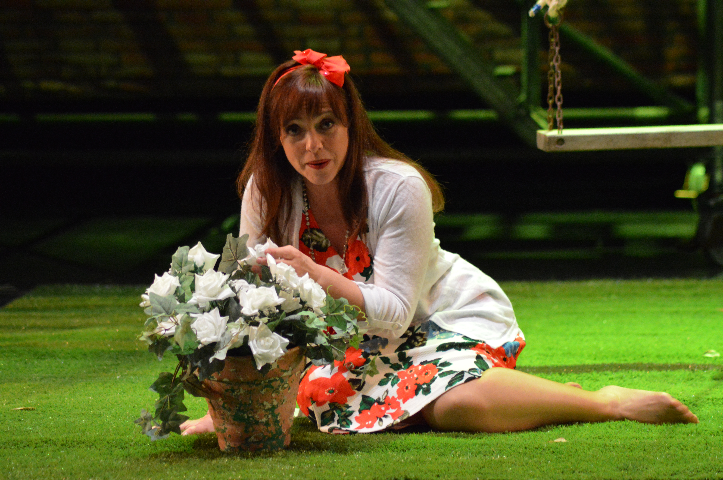
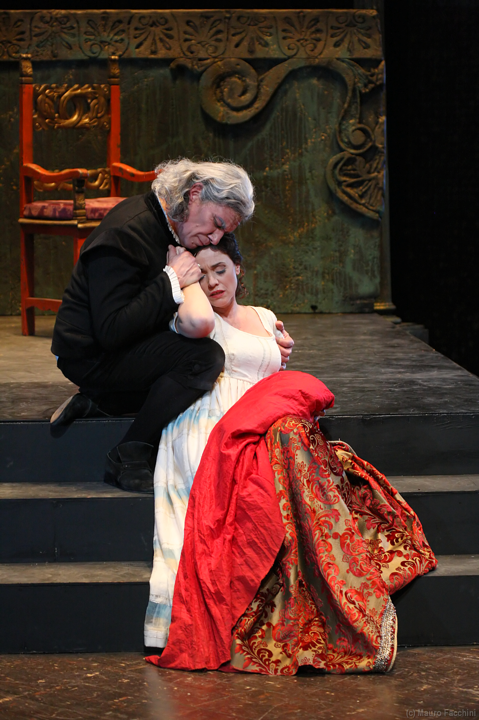 GILDA “RIGOLETTO” TEATRO “COMUNALE” CARP (MODENA)

ELEONORA “IL FURIOSO ALL’ISOLA DI SAN DOMINGO” 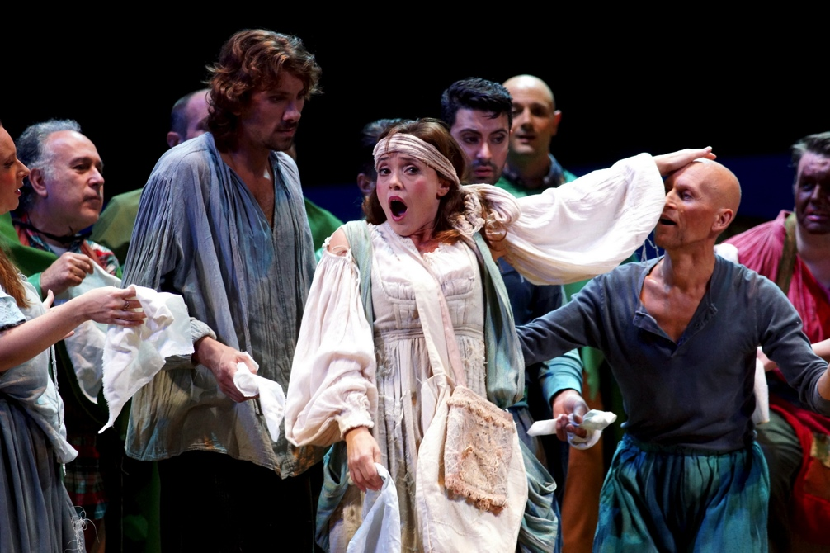
TEATRO “DONIZETTI” BERGAMO, OTTOBE 2013

GILDA “RIGOLETTO” TEATRO “VITTORIO EMANUELE” MESSINA, MARZO 2013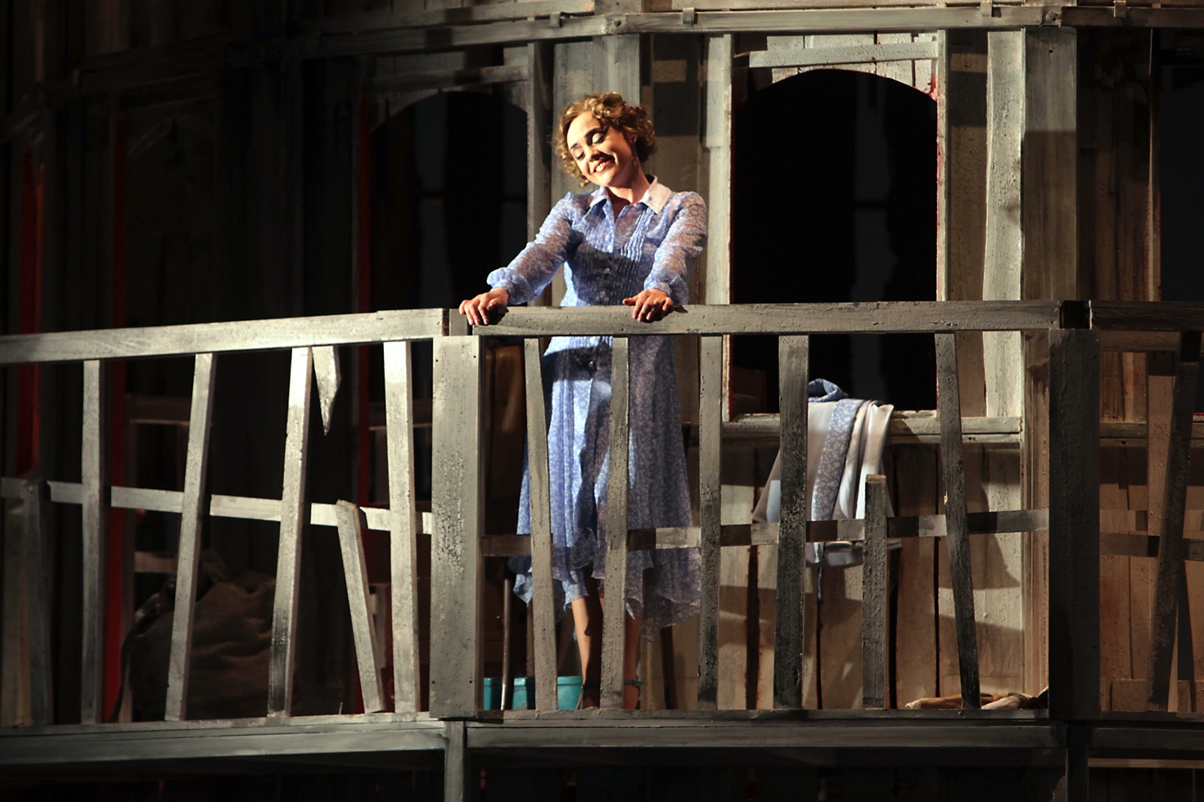

LUCIA “LUCIA DI LAMMERMOOR” TEATRO “VERDI” TRIESTE, GIUGNO 2011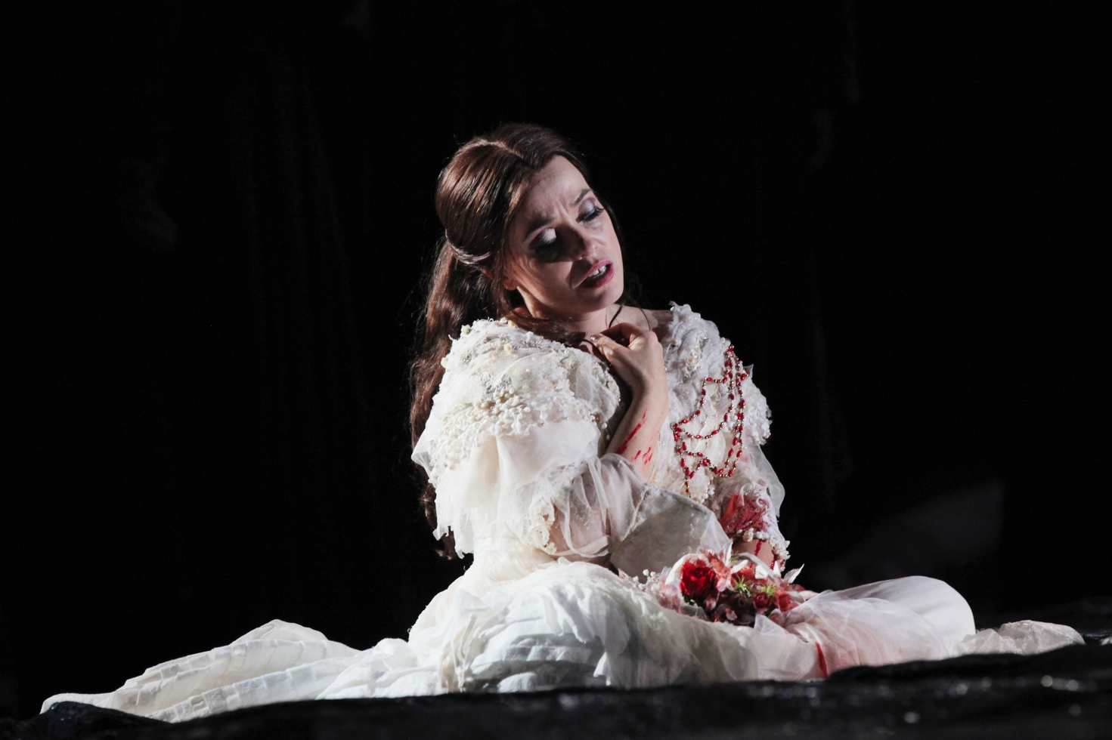

CILLA “IL SOCRATE IMMAGINARIO” TEATRO “LA SCALA” MILANO, OTTOBRE 2007 